Type 1

Left Stick: Movement Y: Green Goggles

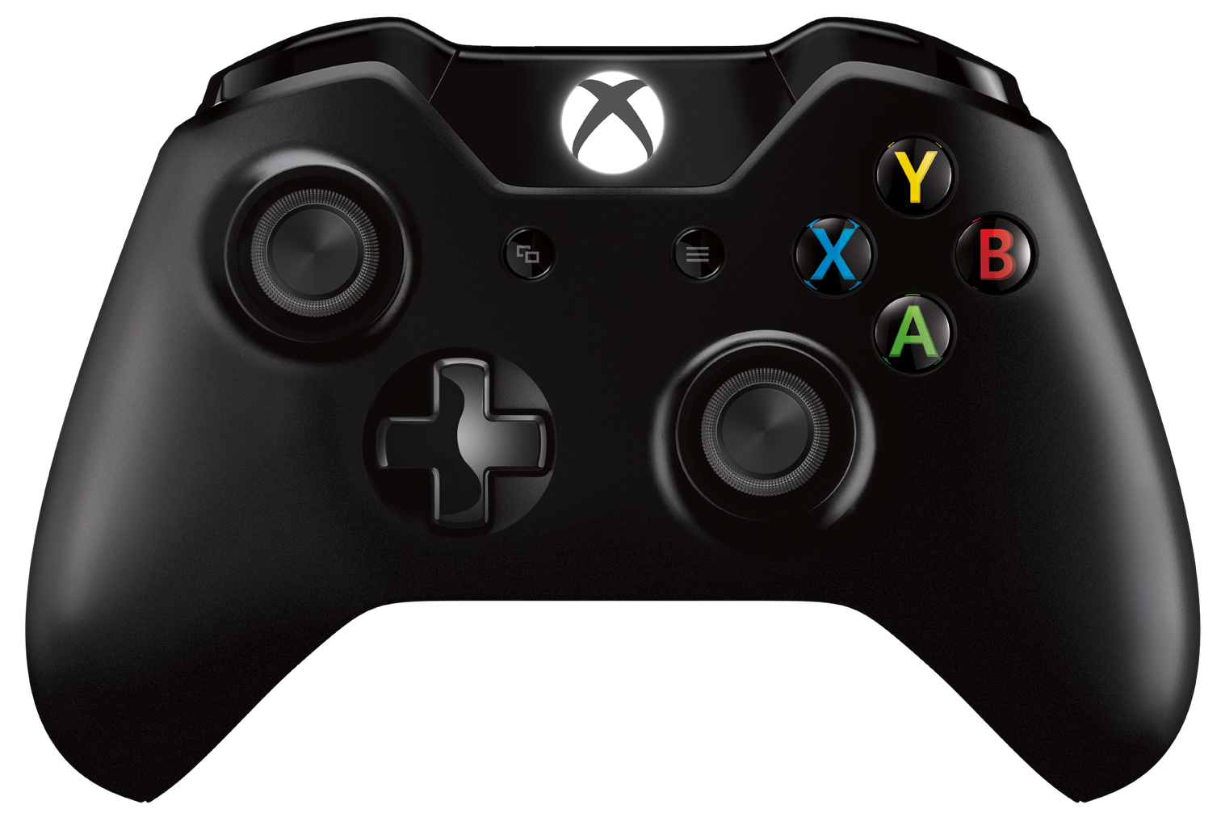

B: Red Goggles

A: Jump Button

X: Blue Goggles

Type 2
Game Start:

Left Stick: Movement A Button: Jump Button

After collecting the Green Goggles:

Left Stick: Movement> Left & Right Y Button: Green Goggles
Activate/Deactivate

A Button: Jump Button

After collecting the Red Goggles:

Left Stick: Movement> Left & Right Y Button: Green Goggles
Activate/Deactivate

B Button:
Red Goggles Activate/Deactivate

A Button: Jump Button

After collecting the Blue Goggles:

Left Stick: Movement> Left & Right Y Button: Green Goggles
Activate/Deactivate

B Button:
Red Goggles Activate/Deactivate
X Button:
Blue Goggles
Activate/Deactivate

A Button: Jump Button

